

**Congregation Brith Sholem**

**Conversion Intake Form**

Congregation Brith Sholem welcomes those who are not already Jewish to learn with us and become part of our community. The path is a rigorous one, and we are committed to providing you with support along the way. In order to help us know you better, and to ensure th at you understand the commitment involved in conversion, we ask that you complete this form and return it to [congregationbrithsholem@gmail.com](mailto:congregationbrithsholem@gmail.com?subject=Conversion).

**Name _________________________________________________­__________­­­______**

**Address _______________________________________________________________**

**City, State, Zip _________________________________________________________**

**Home phone _________________________ Cell phone ________________________**

**E-Mail __________________________________________________________________**

Date of Birth ____/____/________ Pronouns ___________________________________________

Occupation ____________________

Please describe the religious journey that has brought you here.

What hopes and expectations do you have around the conversion process?

Special Skills, Talents, and Hobbies (e.g., musical instruments, photography, baking, sports, crafts) you would be willing to share:

**CONVERSION COMMITMENT**

The path to Judaism will take time, energy, and other resources, including the support of the Brith Sholem community. Brith Sholem will be here with personal and material resources, such as our library. Your studies will be coordinated by our Student Rabbi, with community members available at other times to consult and answer questions. The process usually takes at least one year or possibly two to complete. We ask you to commit to a financial contribution equivalent to one year of synagogue membership, which is detailed below.

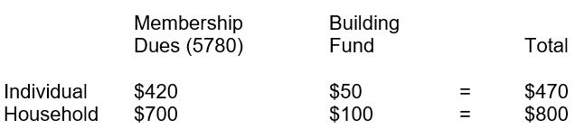

This financial commitment will cover up to 24 months of support for the conversion process; if your conversion is not complete at that time, we will review the commitment.

If you are unable to commit to this amount, please add a note to tell us how much you can commit to. Inability to pay should not be a barrier to your pathway to Judaism, but you should be able to make some kind of commitment.

Payment may be made by check to our PO Box or online via Venmo (@brith-sholem). You can pay over time if you like (please add a note to let us know if you plan to do this).

**SIGNATURE AND DATE**

I understand the conversion process and commitment and hereby declare my intention to satisfy the requirements.

**_______________________________________________________Date____________­­­­_­­­____**

**Please return this form to:**

Congregation Brith Sholem, P.O. Box 9741, Ogden, UT 84409

or by email to [congregationbrithsholem@gmail.com](mailto:congregationbrithsholem@gmail.com)

Date Received __________________________________